**NOTE: This is an official document by Indexademics. Unless otherwise stated, this document may not be accredited to individuals or groups other than the club IDX, nor should this document be distributed, sold, or modified for personal use in any way.**

**Chapter 6: Electronic Structure of Atoms**

**IDX G9 CHEMISTRY S+ STUDY GUIDE ISSUE 3**

**By Kelvin 9(9)**

**6.1 Wave Nature of Light**

Review

* Light is a kind of electromagnetic radiation. An electromagnetic wave consists of electric and magnetic fields oscillating at right angles.
* The distance between corresponding points on adjacent waves is the wavelength (*λ*).
* The number of waves passing a given point per unit of time is the frequency (*ν*).
* The SI unit for frequency is Hertz, or Hz
* The electromagnetic spectrum separates waves into different levels 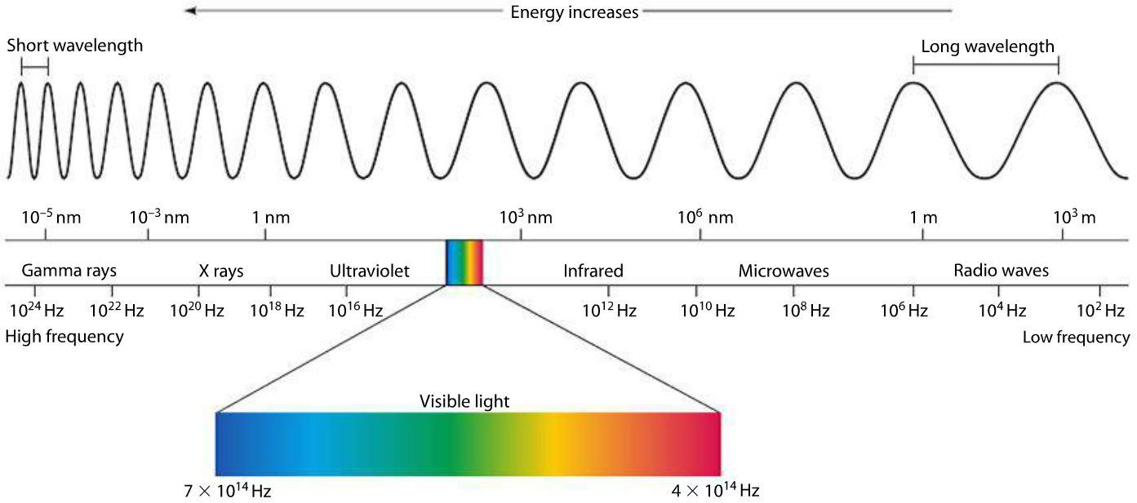
* Wavelength, frequecy, and energy of waves of the visible light spectrum are arranged as following: violet < indigo < blue < green < yellow < orange < red.
* Wave model does not explain how light can form when temperature increases (neon lights)
* Quantum: the smallest amount of energy (in chemistry)
* Formula for 1 quantum of energy: *E* = *h*v
* Photoelectric effect: electrons are ejected when light shines on a metal.
* Kinetic Energy of electron ejected: KE = *Ephoton — Ethreshold*
* Hydrogen Line Spectrum: Electrons can be excited to higher energy levels when it absorb energy. When the atom is in an excited state, the electron can drop from a higher energy level to a lower energy level. As a result, the atom emits a photon corresponding to the difference between the energy levels associated with two orbits. only certain frequencies of radiation can be emitted. A diagram of a shell

  Description automatically generated

6.4 Wave Nature of Matter

* Louis de Broglie theorized that if light can have material properties, matter should exhibit wave properties.
* Formula
* A diagram of a mathematical equation

  Description automatically generated
* Heisenberg Uncertainty Principle: The position and the velocity of a moving electron at one point cannot be measured at the same time

6.5 Quantum Mechanics (VERY IMPORTANT)

* Schrödinger found the quantum mechanical model
* There are three properties of the model
  + The energy of electron is quantized (Bohr model)
  + Electrons exhibit wavelike behavior (de Broglie)
  + The exact position as well as momentum/velocity of an electron at any given point is impossible to know (Heisenberg Uncertainty Principle)
* Solutions to the Schrödinger equation lead to a mathematical expression, called an atomic orbital.
* An atomic orbital is represented pictorially as a region of space in which there is a high probability of finding an electron.

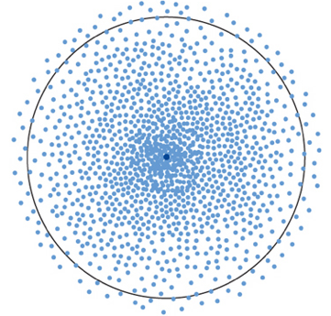

* There are differences between the bohr model and the quantum mechanical model: The bohr model explains how electrons exist in fixed orbits and pathways, while the quantum mechanical model is where electrons exist in a probability-based region of the atom

6.6 Representation of Orbitals

* The quantum mechanical model provides theory of the existence of different atomic orbitals
* The atomic orbitals can be classified as: S, P, D, and F
* Each orbital can hold up to no more than 2 electrons each
* A diagram of a flower

  Description automatically generated
* For every principle energy level (in the section later), there is 1, 3, 5,7 orbitals for the s,p,d,f shells, as the orientation of the shells may be different in a 3d plane
* The principal quantum number, *n*, always equals the number of sublevels within that principal energy level.
* A diagram of energy and energy

  Description automatically generated
* Critical thinking question: how does the size and shape of the orbitals change as the principal quantum number changes in a hydrogen molecule? What about in a multi-electron system?

6.7 Electron Structure of Atoms (Notice that there is a difference in structure of hydrogen atom and a multi-electron atom)

* Degenerate orbitals: orbitals with the same energy
* The electron structure of atoms are involved in a pattern, going from s to p to d then to f, as the charges of each orbital increase with the principal quantum number
* In the quantum mechanical model’s electron configuration, there are three rules that you need to follow. THESE RULES ARE IMPORTANT AND DEFINITELY WILL BE ON THE TEST
  + The Aufbau Principle: Electrons occupy orbitals of the lower energy first
    - As mentioned, the charge of the orbitals are arranged as the following in the same principle quantum level: s<p<d<f
  + The Pauli Exclusion Principle: No two electrons in the same atom can have the same quantum number.
    - Translation: the quantum number is divided into many portions. You can understand it as there are different conditions to identify an electron. For example, an electron can be identified by its pqn, its type of orbital, its direction of spin, etc.
    - As a result, no electron of the same orbital can have the same direction of spin, and each orbital can only hold 2 electrons
* The Hund’s Rule: For degenerate orbitals, the lowest energy is attained when the number of electrons with the same spin is maximized.
* Translation: to keep the electron configuration accurate and stable, for each orbital of the same energy, the number of electrons with the same spin must be greatest

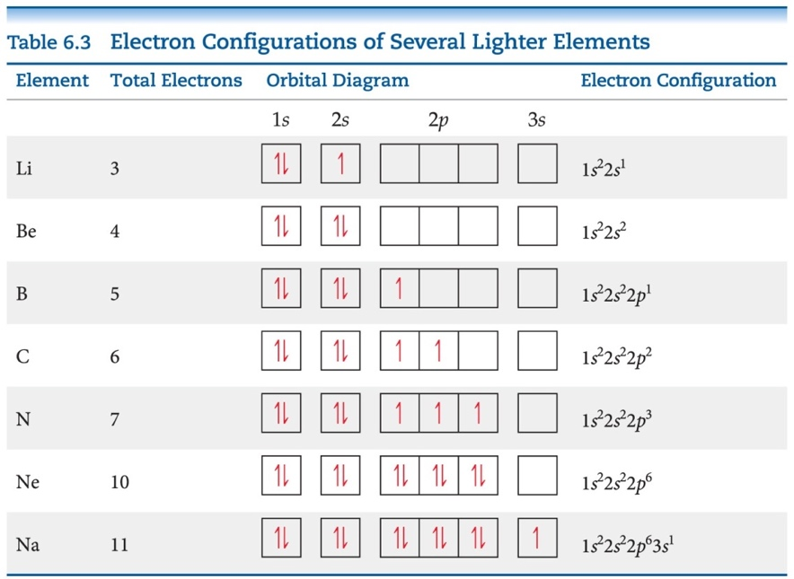

* Electron configuration: the arrangement of electrons into the different subshells of different energy levels in a quantum mechanical model
* The electrons, as the Aufbau principle writes, are arraged from lower to higher energy levels

* The first number is the principal quantum number, the letter is the orbital type, and the “exponential” on the right is the number of electrons in each subshell
* (Note: The configuration of electrons is very difficult to explain and requires lots of practice to understand. You should know how to do your homework.)
* Abbreviated configuration: The configuration of electrons of elements can be written as the closest noble gas element (must be smaller than the element itself) added with the additional subshells following it. Example: Cl: [Ne] 3s2 3p5
* The inner-shell electrons are referred to as the core electrons.
* The electrons given after the noble-gas core are called the *outer-shell electrons*. The outer-shell electrons include the electrons involved in chemical bonding, which are called the valence electrons.
* For the elements with atomic number 30 or less, all of the outer-shell electrons are valence electrons.
* Electron configuration of ions: First write configuration of the element’s neutral state, then decide whether to loose or gain electrons based on whether it is a cation or an anion.
* Some actual electron configurations differ from those assigned using the aufbau principle because although half-filled sublevels are not as stable as filled sublevels, they are more stable than other configurations.
  + Cr: 1*s*22*s*22*p*63*s*23*p*63*d*54*s*1
  + Cu: 1*s*22*s*22*p*63*s*23*p*63*d*104*s*1

Uncertainty and Significant Figures

* Uncertainty: Measurements in chemistry might be inaccurate by eye. This will create uncertainty or being unsure of the exact value of something. The uncertainty is calculated by half of the scale graduations
* To evaluate the accuracy of the experimental data, you may calculate the difference between experimental value and accepted value.
* Error = experimental value – accepted value
* Can be negative
* 
* Systematic error:
* incorrectly zeroed balance
* poorly calibrated or badly made instruments
* instrument parallax error (reading a scale from a position that is not directly in front of the scale)
* improper conditions
* Errors come from procedures, methods or theories
* Systematic errors cannot be reduced by repetition.
* Poor precision in measurements is associated with random uncertainty.
* Error associated with estimating the last digit of a reading is called random uncertainty. Random uncertainties arise mostly from limitations in the instrument.
* This type of error is such that the value recorded is sometimes higher than the true value, sometimes lower.
* Repeating the measurement a number of times and averaging the results reduces the effect of random uncertainty.
* Usually，only one significant figure should be kept.
* Percentage uncertainty: The percentage uncertainty changes with the amount of material that you are measuring. Percentage uncertainty is also a guiding factor in choosing equipment for an experiment.
* A screenshot of a math problem

  Description automatically generated
* A math equations on a white background

  Description automatically generated